RNQG BOUTIQUE WORKSHOP
ROPE BOWLS (WITH OR WITHOUT FABRIC), COASTERS, ETC…
Instructor: Jacqui O’Brien
Ann’s Fabrics, 235 Turnpike St., Canton
Oct 3, 2026, 10-2pm

Try your hand at making these fun objects from clothesline rope: bowls of all sizes, coasters, trivets, etc. You can make your item with or without wrapping the rope in fabric. If leaving plain (without fabric), consider using contrasting thread to make a design statement.

FOOD:
Consider bringing a snack/beverage. Please make sure the beverage is covered, avoid spillage.

TAKE HOME INSTRUCTIONS: Since we would like to have as many bowls, trivets, coaster sets, etc… for our Boutique, you will be given a full instruction doc during the class to take home in hopes of making even more for our Boutique.

PREPARATION:
Consider if you want to wrap the bowl in fabric or simply keep it as rope only. Think about the thread choose, as the thread will be noticeable, choose coordinating thread or contrasting thread to show off the thread. See pics for some inspiration. If using fabric to wrap the rope, please prep the fabric (cut strips) before the class so that you can get right to sewing.

SUPPLY & EQUIPMENT LIST:
- THE INSTRUCTOR WILL SUPPLY 50 FEET OF ROPE FOR THE CLASS, enough to make a bowl or a few coasters or a trivet. If you have clothesline rope, feel free to bring it along, but it should be new not used. Should you want to make more bowls, 100% cotton. DO NOT use nylon/plastic covered rope. Walmart Mainstays brand is good. Ropes now come in many colors, check out online craft stores!
- Sewing Machine
- Zigzag foot and Zigzag throat plate.
- Threads to sew the rope together. The thread shows, so think about your design. Plenty of pre-wound bobbins in the same thread will save you time, project uses a lot of thread.
- Fabric, if you choose to wrap your rope in fabric. 50-75 feet if planning on covering all the rope. You will need fabric strips in 1 – 1.5-inch wide, if NOT using scraps and cutting from yardage, consider cutting on the bias, it’s not required, but can assist in wrapping the rope. The strips DO NOT need to be sewn together.
- Needles at least 80/12 or better (100/14) bring a few, it’s possible you could break a needle.
- Wonder clips, or clothes pins or large binder clips. INSTRUCTOR WILL SUPPLY CLOTHES PINS if necessary.
- A couple (2-3) long heavy-duty pins (daisy head flat pin types are good). These pins will be going through several strands of clothesline they need to be sturdy (Pins are only needed for the beginning of the process).
- Scissors
- Stiletto (optional)

SPECIAL COMMENTS:
Please look on Pinterest and watch YouTube videos to get familiar with the techniques and decide what you want to make (bowl, Trivet, mug rugs, etc..), with or without fabric

THANKS FOR CONSIDERING TAKING THE WORKSHOP TO BENEFIT OUR GUILD BOUTIQUE!!

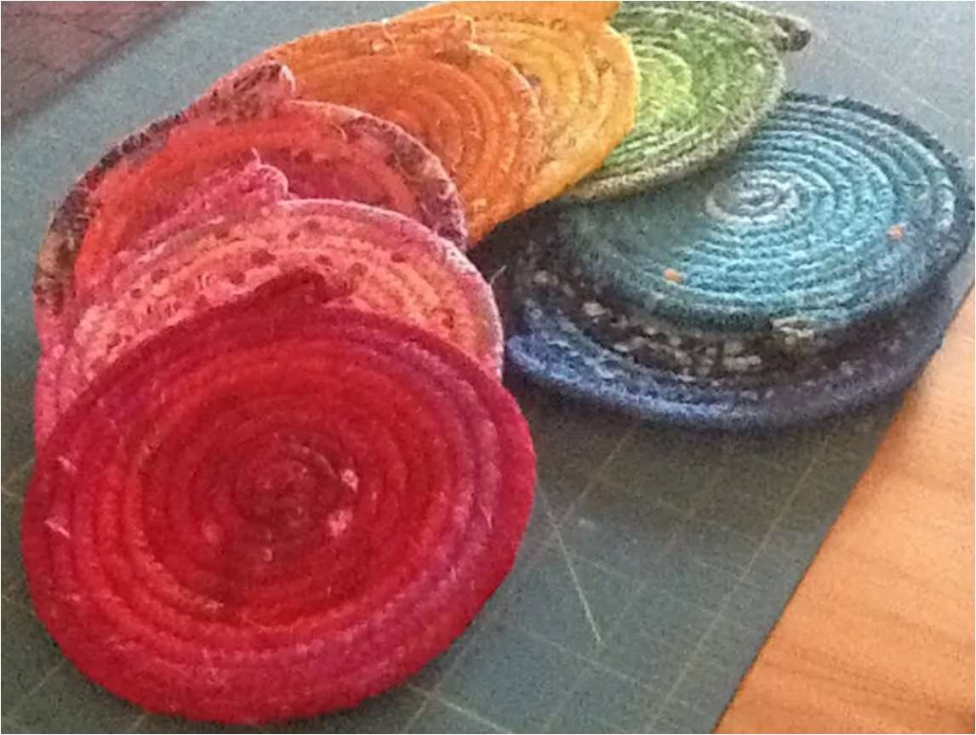
Coasters

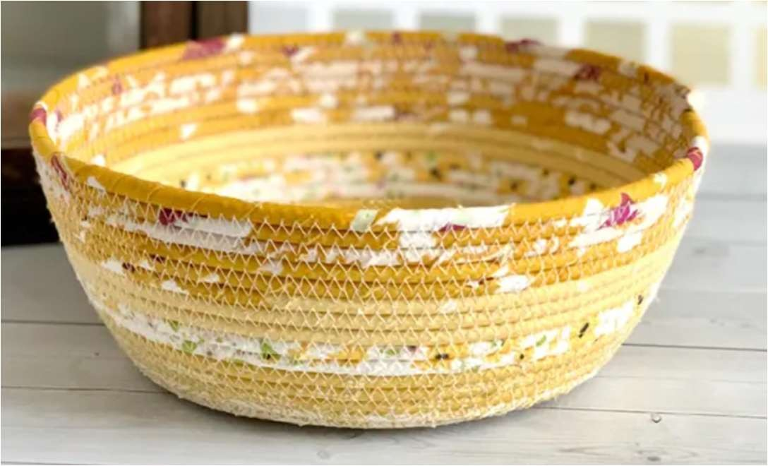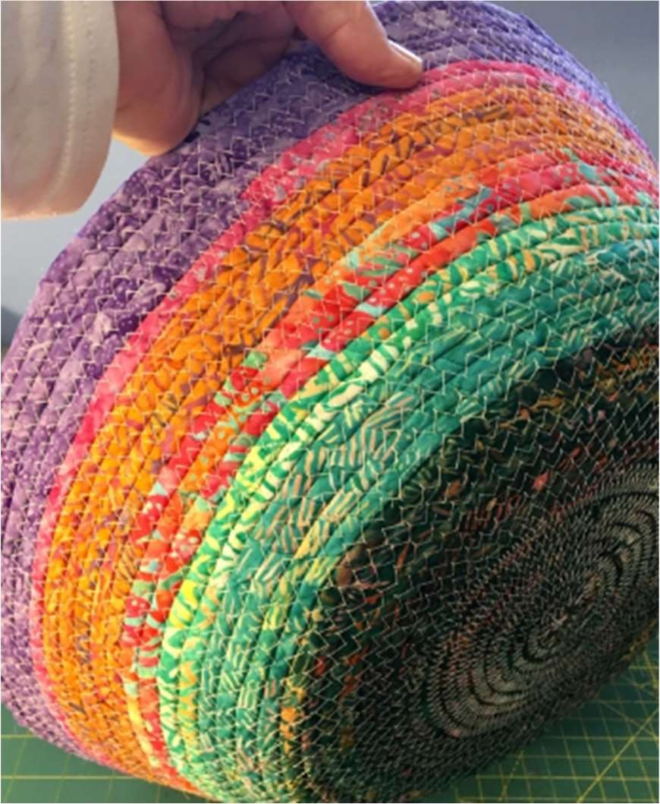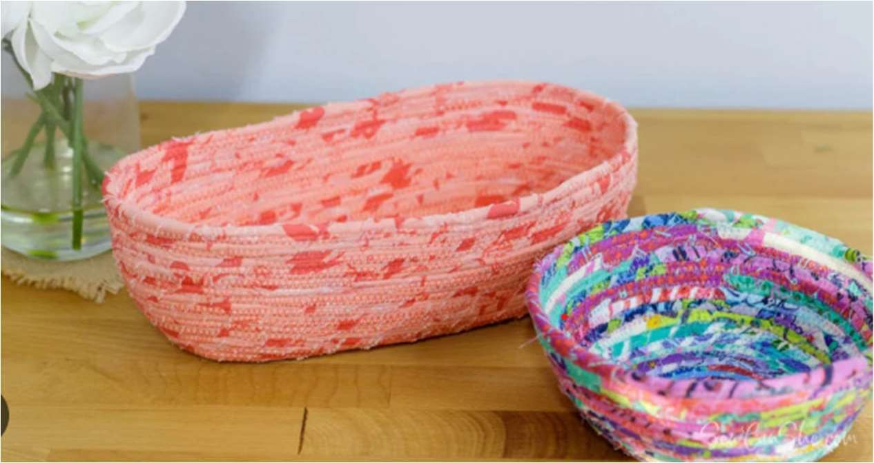
Fabric covered Bowls

Rope Bowl, no fabric, contrasting thread
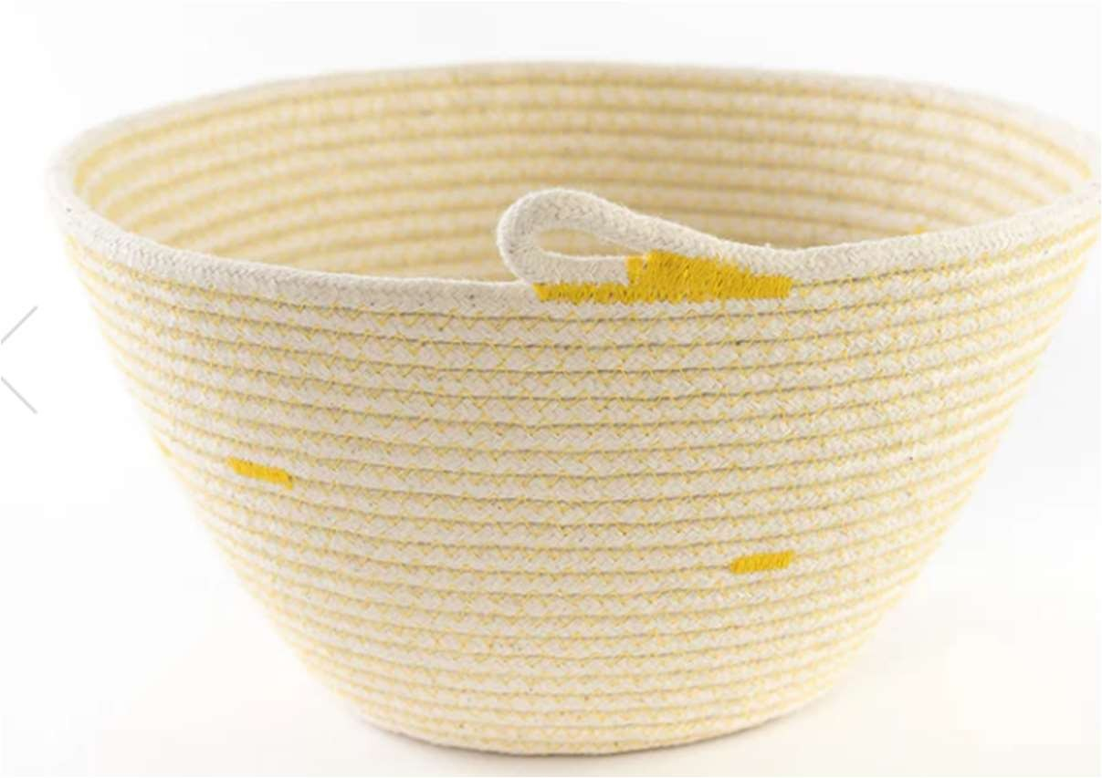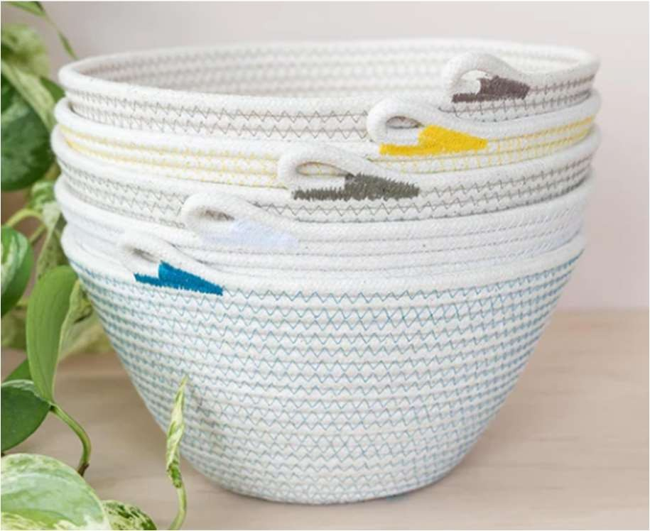

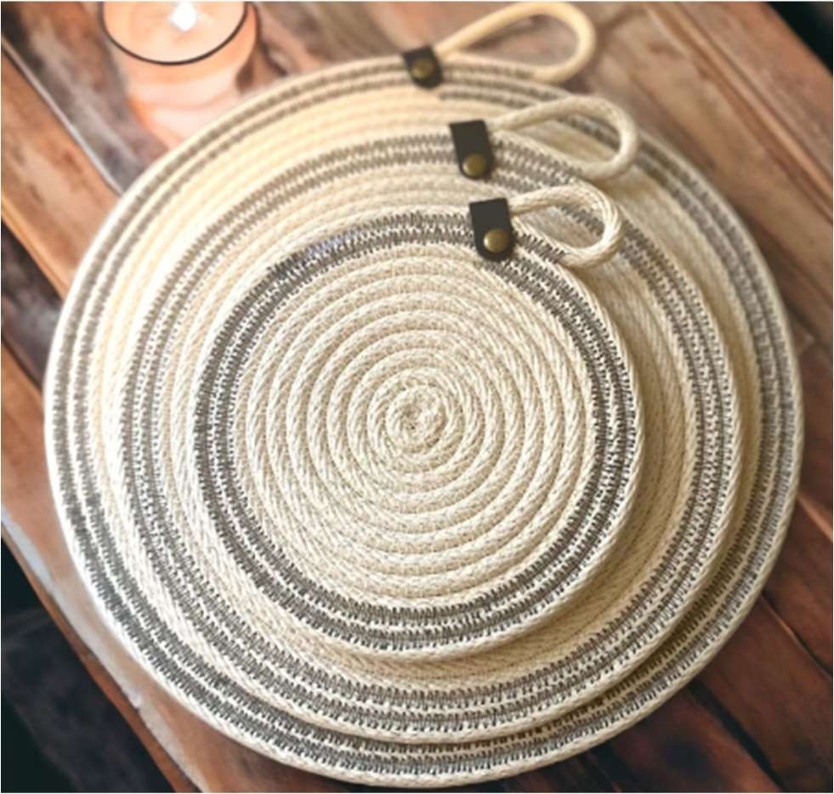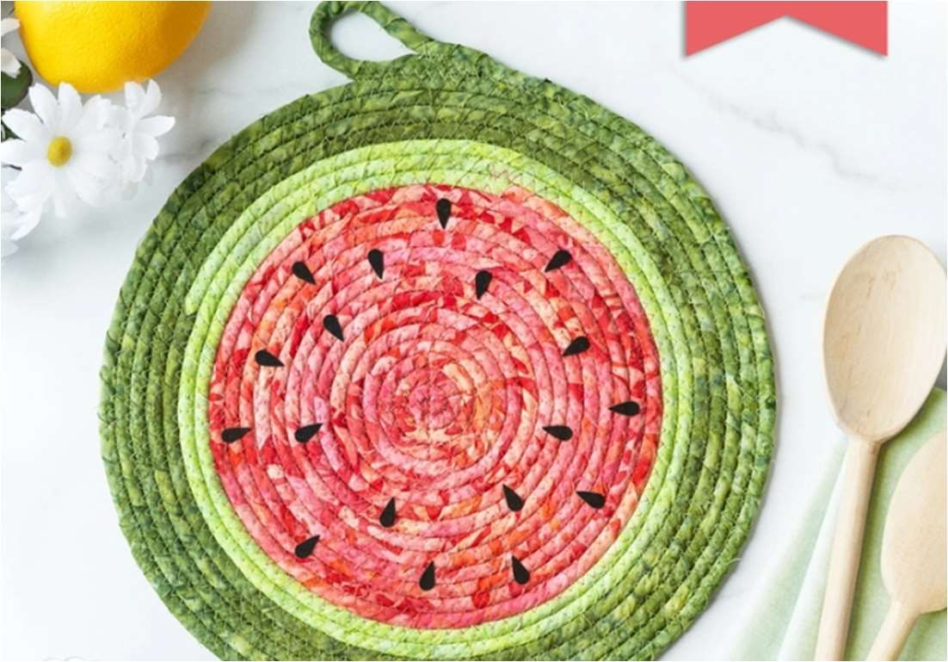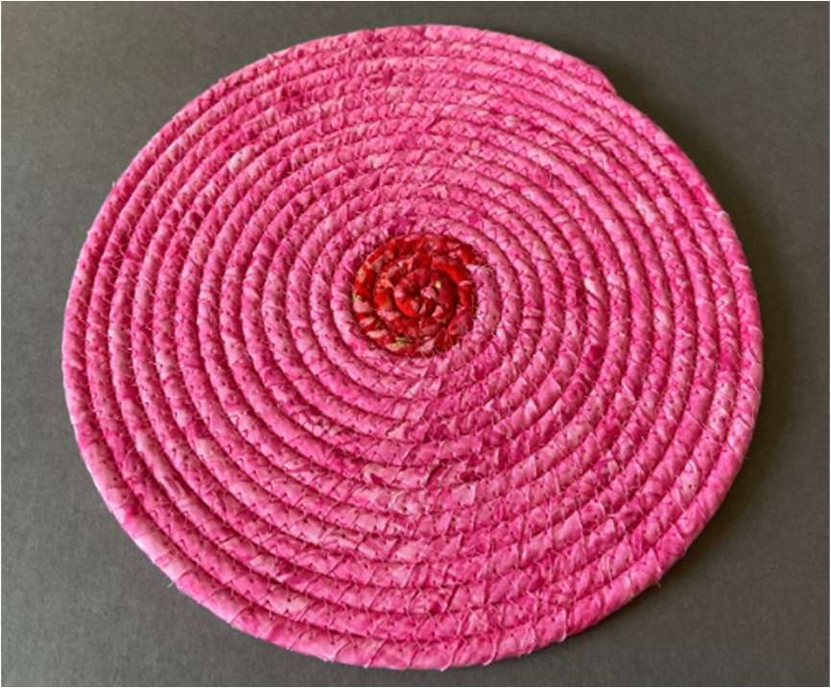

Trivets

